Access Technology: Support to the school curriculum
by Melissa Fanshawe

Technology is required to work and live in society, stay connected and obtain information (Parette & Blum, 2013). The National Curriculum places a focus on technology as a necessary tool for learners of the 21st Century (Australian Curriculum Assessment and Reporting Authority, 2012).
Students with vision impairment are capable of the same academic learning as their peers (Wolffe, 1999) and should be expected to meet the curriculum requirements of their year level. Learning is very visual in nature, and students with no or low vision need modifications to the curriculum and assessment to access at the same level as sighted peers (Blatch, Nagal, & Cruickshank, 1998; Gentle, 2014; Holbrook & Koenig, 2000).

Technology
Technology plays a vital role in linking students with vision impairment to the curriculum (F. D'Andrea, 2012; Parette & Blum, 2013). The availability of access technology has expanded significantly in the past two decades (Hollier & Murray, 2006) as more suppliers are considering the needs of all community members when developing new products (Weerakkody, Dwivedi, El-Haddadeh, Almuwil, & Ghoneim, 2012).
There are many blind-specific products and general technology products on the market that enable students with vision impairment to access the curriculum (Kelly, 2009). Products such as magnification tools, speech readers and tactile braille devices mean that students with vision impairment are on a more level playing field in accessing the curriculum as their sighted peers (Casey, 1997; Farnsworth & Luckner, 2008; Middleton, 2009; Shinohara & Tenenberg, 2009).
There are two very important considerations for students with vision impairment using technology to access the curriculum; (i) selecting the best devices for their individual needs (Bickford & Falco, 2012; Casey, 1997) and (ii) learning how to use the tools to maximise participation in learning (F. D'Andrea, 2012; McNear, 2006; Such & Whittaker, 1999). It is essential for the Vision Impaired Specialist and Classroom Teacher to work together with technology specialists to facilitate the best use of technology in the classroom.
This article will discuss the benefits of three pieces of technology in the classroom to access the curriculum; magnification, braille devices and the iPhone.

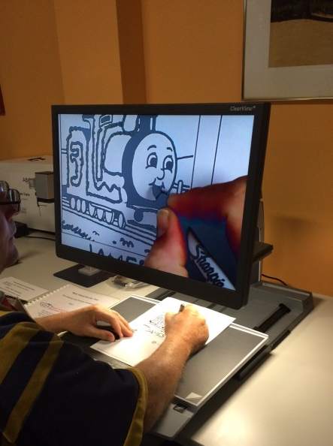
Magnification – maximising visual efficacy
For young children with small amounts of vision, it is important that they have access to as much visual information as possible to stimulate development (Casey, 1997). Magnification in the form of optical devices and screen readers allow students with vision impairment the ability to enlarge items to see some detail.
Show and tell items can be displayed under a Closed Circuit Television camera to allow children to see legs on a beetle, an electronic magnifier can be placed over a book so students can see the picture cues, or an Optical Character Recognition Device (OCR) may scan an image and convert it to text. The text can then be magnified and read by a screen reader to the student, so they can follow along with the words.

Figure 1: Magnification device (CCTV) Source: Author’s own photo
All these steps are vital in early literacy development (Casey, 1997) and are made possible because of magnification. Screen magnification will allow children to “explore a range of options that can enhance their access to computers ... and an understanding of their vision-related needs when accessing computers (Knight, 2014, p. 10).

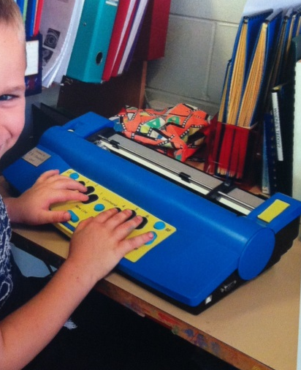
Braille devices – linking to language and literacy
With the introduction of OCR scanners, speech output and screen reading software, there is great debate in the community over whether braille is still a necessary tool for education (Mates, 2011; Sullivan, 1996). A decline in braille instruction correlates with advances in technology and access to information through screen readers and voice input (Bonnie-Miller, 2009; Chung, 2006).

Figure 2: Braille Device (Mountbattan). Source: Author’s own photo
When learning to read, teachers are trying to develop oral language, listening comprehension and print knowledge (D’Andrea & Barnicle, 1997). Braille teaches print concepts such as spelling, grammar, punctuation (Mates, 2011). People with vision impairment with all three reading skills, have significantly higher chances of furthering their education and obtaining paid work (Blind Citizens Australia, 2013).
Braille can be used on standalone machines such as Perkins brailler, Tactrapoint or Jot a Dot. Braille devices can be connected by cable or bluetooth to computers on machines such as the Mountbattan Brailler, Smart Perkins, Braille Note, Focus, or other refreshable braille display devices. These enable students to connect and communicate with their teachers and their peers (D’Andrea & Barnicle, 1997). Braille devices encourage development of print literacy and increase opportunities in higher education and employment (Bonnie-Miller, 2009; McMillin, 2009). The use of braille and explicit teaching of braille devices are therefore essential to teach language and literacy to students with vision impairment (Bonnie-Miller, 2009; Chung, 2006; Parette & Blum, 2013).

iPhone - a portable computer
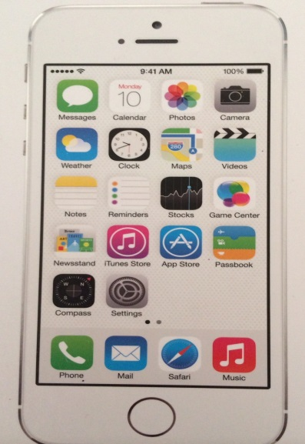
The increasing importance of computers as a tool in education has been well documented in literature (Parette & Blum, 2013; Weerakkody et al., 2012; Williams & McClintic, 2005). iPhones are rapidly gaining prominence in education due to their small and portable size, internet accessibility and the capability of the iPhone processor (Hakobyan, Lumsden, O’Sullivan, & Bartlett, 2013; Meng Ee WongTan, 2012).
Figure 3: Mainstream Technology (iPhone) (Source: Author’s own photo
Although “touch screen technology can present significant barriers for blind users” (Meng Ee WongTan, 2012, p. 646), accessibility features such as Voiceover, Gestures, Dictation, Rotor and Siri (Apple Inc., 2014) mean that the small screen size does not impact usability. The iPhone’s ability to access the internet, mail, and word applications all in one device, makes the iPhone an excellent portable computer for learning.
Students can dictate assignments, access information from webpages, join accessible webquests and access school learning areas (Haynes, 2014). A number of Apps, both specifically designed for blind users along with generic applications, provide learning opportunities to meet the National Curriculum. Bluetooth keyboards or refreshable braille display devices can be used to be able to enter and retrieve data. By using the iPhone as a portable computer to interact with learning, technology is able to be integrated into the curriculum as a useful tool for learning (Parette & Blum, 2013).

The importance of technology in the 21st century is paramount for all students to access the National curriculum and crucial for students who are vision impaired (F. D'Andrea, 2012). Teachers need to assist students to find the best products that promote visual efficacy and teach language and literacy. By providing useful technology and assisting students to learn how to use it, we will enable students with vision impairments to be able to access the curriculum.

References:
Apple Inc. (2014). Features that are helpful beyond words. Retrieved from http://www.apple.com/au/accessibility/ios/#vision
Australian Curriculum Assessment and Reporting Authority. (2012). The Shape of the Australian Curriculum. Retrieved from www.acara.edu.au
Bickford, J., & Falco, R. (2012). Technology for early braille literacy: Comparison of traditional braille instruction and instruction with an electronic notetaker. Journal of Visual Impairment & Blindness, 106(10), 679 - 693.
Blatch, P., Nagal, G., & Cruickshank, L. (1998). Current Practices and Future Trends. In P. Kelley & G. Gale (Eds.), Towards Excellence (pp. 17-32). North Rocks, Sydney: RIDBC.
Blind Citizens Australia. (2013). Inquiry into improving the employment participation of people with disability in Australia. Retrieved from www.bca.org.au
Bonnie-Miller, R. (2009, 2009 Apr 17). Few blind people use Braille, and fewer visually impaired children learning it, McClatchy - Tribune News Service. Retrieved from http://search.proquest.com/docview/456792809?accountid=10499
Casey, J. (1997). Early literacy : the empowerment of technology. Englewood, Colorado Teacher Ideas Press.
Chung, J. (2006, 2006 Jun 25). Reading at Their Fingertips; National Braille contest draws blind and visually impaired youth from throughout the country. Organizers say learning it is key to employment, Los Angeles Times, p. 0. Retrieved from http://search.proquest.com/docview/422069372?accountid=10499
D'Andrea, F. (2012). Preferences and Practices Among Students Who Read Braille and Use Assistive Technology. Journal of Visual Impairment & Blindness, 106(10), 585-596.
D'Andrea, F. M., & Barnicle, K. (1997). Access to Information: Technology and Braille In D. Wormsley & F. M. D'Andrea (Eds.), Instructional Strategies for Braille Literacy. New York, NY: AFB Press.
Farnsworth, C., & Luckner, J. (2008). The impact of assistive technology on curriculum accommodation for a braille-reading student RE:View, 39(4), 171-187.
Gentle, F. (2014). Curriculum and pedagogy for students with vision impairments [Lecture Notes]. Retrieved from University of Newcastle, RENWICK School of Education, Sydney : https://uonline.newcastle.edu.au/
Hakobyan, L., Lumsden, J., O’Sullivan, D., & Bartlett, H. (2013). Major review: Mobile assistive technologies for the visually impaired. Survey of Ophthalmology, 58, 513-528. doi: 10.1016/j.survophthal.2012.10.004
Haynes, K. (2014). 12 Easy Ways to Use Technology in the Classroom. Retrieved from http://www.teachhub.com/12-easy-ways-use-technology-your-classroom-even-technophobic-teachers
Holbrook, M. C., & Koenig, A. (2000). Basic Techniques for Modifying Instruction. In M. C. Holbrook & A. Koenig (Eds.), Instructional strategies for teaching children and youths with vision impairment (Vol. 2, pp. 173 - 193). New York, : NY: AFB Press.
Hollier, S., & Murray, I. (2006). The evolution of e-inclusion: Technology in education of the vision impaired . Retrieved from http://digitalcommons.ilr.cornell.edu/gladnetcollect/341/.
Kelly, S. (2009). Use of assistive technology by students with visual impairments: findings from a national survey. Journal of Visual Impairment & Blindness, 103(8), 470-480.
Knight, M. (2014). Early learning access technology framework for children who are blind or have significant vision impairment. RIDBC. North Rocks: Sydney.
Mates, B. (2011). Touching the internet: Braille access to the internet. In B. Mates (Ed.), Assistive Technologies in the Library. Retrieved from http://site.ebray.com/id/10469321?ppg=74.
McMillin, S. (2009, 2009 Jan 05). Campaign tries to teach the benefits of Braille: Learning the system is linked to employment, McClatchy - Tribune Business News. Retrieved from http://search.proquest.com/docview/456352296?accountid=10499
McNear, D. (2006). Aligning braille literacy and assistive technology skills with ISTE educational technology standards. journal of the South Pacific Educators in Vision Impairment, 3(1), 48-49.
Meng Ee WongTan, S. S. K. (2012). Teaching the Benefits of Smart Phone Technology to Blind Consumers: Exploring the Potential of the iPhone. Journal of Visual Impairment & Blindness, 106(10), 646-650.
Middleton, H. (2009). Technology, Learning and Working: Blind and Vision Impaired's Use of Technology. Retrieved from http://www.griffith.edu.au/__data/assets/pdf_file/0006/38382/AFB-Project-Report_ES_Final.pdf
Parette, H., & Blum, C. (2013). Instructional Technology in Early Childhood: Teaching in the Digital Age. Baltimore, Maryland: Paul H. Brookes Publishing.
Shinohara, K., & Tenenberg, J. (2009). A Blind Person's Interactions with Technology. Communications of the ACM, 52(8), 58-66. doi: 10.1145/1536616.1536636
Such, G., & Whittaker, S. (1999). Computer assistive technology for the low vision patient. In R. Brilliant (Ed.), Essentials of low vision practice (pp. 291-300). Boston: Butterworth-Heinemann.
Sullivan, J. (1996). What the Future Holds for Braille. from http://www.duxburysystems.com/hksb96.asp
Weerakkody, V., Dwivedi, Y., El-Haddadeh, R., Almuwil, A., & Ghoneim, A. (2012). Conceptualizing E-Inclusion in Europe: An Explanatory Study. Information Systems Management, 29(4), 305-320. doi: 10.1080/10580530.2012.716992
Williams, J. M., & McClintic, H. (2005). Digital Technology Offers New Opportunities to People with Disabilities. Exceptional Parent, 35(12), 34-40.
Wolffe, K. E. (1999). Conveying High Expectations. In K. E. Wolffe (Ed.), Skills for success: a career education handbook for children and adolescents with visual impairments (pp. 279-297). New York, NY: AFB Press.

